# Examples

<https://farm.kleinig.org/>

Need to login. Created by me and my brother.

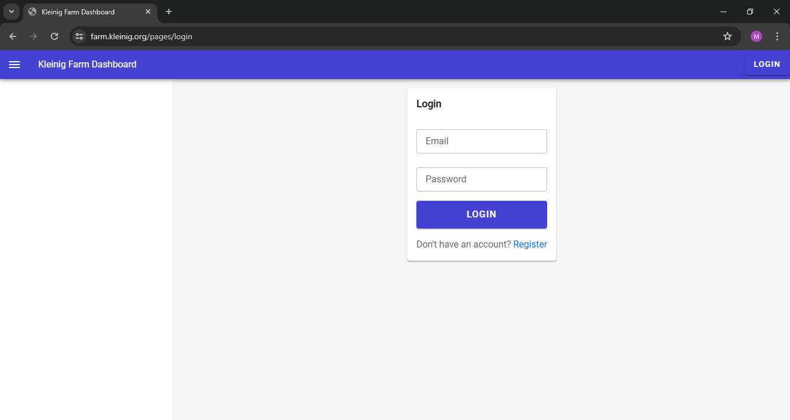

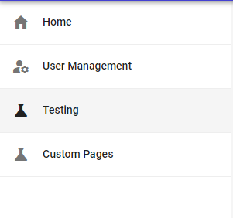

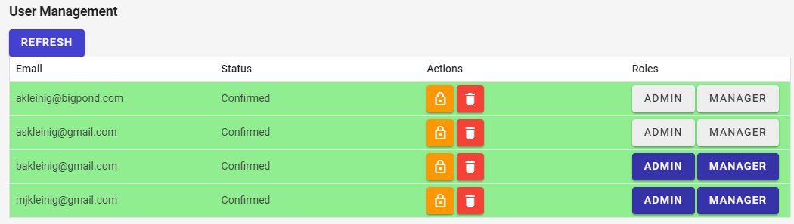

# Vertical vs Horizontal Navigation

<https://vpon.me/articles/vertical-vs-horizontal-navigation>

No clear answer as to which one is better. Horizontal should be used for a small number of links, and vertical for many links (or links with long names).

Every link should have an icon associated with it for better accessibility.

Any time the user needs to input text (for example, email), there should be placeholder text.

# Pure-min.css from Practical 6

<https://unpkg.com/purecss@1.0.0/build/pure-min.css>

# Page Ideas

* Initial page shows public announcements.
* At the top, there are login and sign-up buttons.
* Logging in and sign-up could follow the example from above.
  + Will have to be verified by admin.
* An events page for managers.
* A user management page for admins.

## Users

* A button appears to join a volunteer organisation.
  + Search for ones not signed up. The user will input text, and organisations starting with the text will be displayed.
  + If the text is empty, display all.
* See private comments from volunteer organisations.
  + Includes the comment and which organisation (as a user can be part of multiple).
  + Can filter to see from one organisation.
* See upcoming events from organisations, with a button to RSVP.
  + Users may want to cancel or see which events they’ve RSVP’d to. So, we still need to show all of them to the user.
  + User can filter to see events that have not been RSVP’d to, and ones that have (to cancel), and to filter for a specific organisation.
* User can edit user information.
  + Username.
  + What other information is required?

## Managers

* A manager would login the same way as users, as the information about whether a user is a manager is stored in the database.
* In addition, the page will show more buttons.
  + Viewing members, which will be shown as a list.
  + A button to post updates.
    - Checkbox for whether update is public or private (default private).
  + A button to create events.
    - For users to RSVP.
    - Will show a list of users that have RSVP’d.
    - Hovering over someone’s username will display their email as users may change their username.
  + A button to update events. What needs to be updated?

## Admins

* Login same way as a user/manager.
* A page to verify users.
  + Probably in tabular format.
  + Can filter the page to show all users that have not been verified.
    - Once we can use SQL commands in JavaScript, this will be used.
  + Sometimes, an admin may want to remove a user.
    - Include a button to do this.
  + Can set a verified user to a manager.
  + Can set a verified user to an admin.